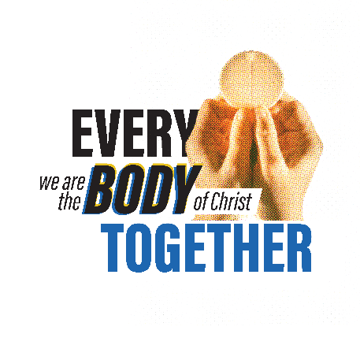
Parish Phone Call Script:
- Before each call recite the following or similar prayer:
Come Holy Spirit, open for me an opportunity to help this family who I am about to call. Help me communicate your love and open their minds and hearts to hear your message. May our parish be renewed through the power of the Holy Spirit. In Jesus name I pray, Amen.
- Call: Hello, this is [___], and I’m calling on behalf of [pastor / parish], may I speak to [Name of Parishioner]

- Contact not available or Answering machine:
Parishioner not available? When is a good time to call back ____? Thank them for their time.
Answering machine? Leave a detailed voice message:
"Hello this is _____ from ____ Parish. We're calling each of our parishioners on behalf of Fr. _____ to let you know the good news about the parish reopening plans as the dispensation for mass attendance is ending on [Date of lifting]. We also would like to hear from you if you have questions, concerns, or can help us. We want to let you know how much the parish values your participation and we hope to see you soon. Our community has continued to grow during covid-19 and we asking each family to come and help us make our parish and liturgies better than ever. Please call me back at ______
- Person is available:
As I said we are calling each of our parishioners on behalf of Fr. _______ We especially want you to know about our parish reopening plans and ask, what has been your mass experiences during covid-19? (this allows the caller to learn whether or not the parishioner has been attending mass in person or digitally) Provide major parish re-opening plan details, for example: Mass times, capacity restrictions, cleaning frequency, mask. social distancing policies etc…
Know that we value your participation and we hope to see you soon. Together, we are the body of Christ! The parish community has continued to grow during covid-19 and we asking each family to come and help us make our parish and liturgies better than ever. Share any additional parish events happening to invite parishioners back (outdoor mass, etc..)
Do you have any questions or concerns about coming back? _________ We ask that, if possible you contact others and share our parish plans and invite them to return to mass.
VERIFY CONTACT INFO (email address) & say: If you have additional questions please visit www.archstl.org/we-are-the-body-of-christ for details on the dispensation and visit [parish web page] for specifics on what your parish is doing.
- Closing:
Ask: Are you comfortable if we prayed right now on the phone and do you have any intentions we could pray for?
If yes, offer this or similar prayer:
Dear God, please bless [person, family?]. Help each of us to love our neighbor and be thankful for our faith and our parish. Enkindle in us a new and powerful love of the Mass in order to help our community, parish, and home. Bless and heal those still being affected by covid and speed our parish community back to health in all areas. We ask in Jesus name, Amen.
Thank them for their time and let them know we look forward to seeing them soon!

