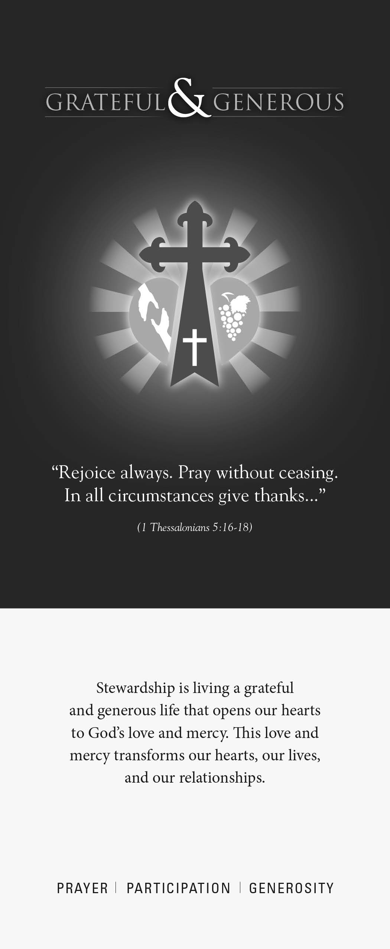

**Generosity** is our response as stewards of God’s many gifts. We use our financial resources to serve others, strengthen our parish, enliven Catholic education and help others meet the needs of the church.

My/Our regular offering

**HAS BEEN** $ per □week □month

My/Our intention for my/our regular offering

**WILL NOW BE** $ per □week □month

**SIGNATURE**

**PRINT NAMe**

**DATE**

**PHONe**

**email**

**□ ** I wish to receive information about including the parish in my Will or Trust and Estate Planning.

**□ **I wish to receive information regarding online giving.

This card is only an expression of your intention to give back to God a faithful and generous share of the gifts He has entrusted to your care. It is not legally binding. Your actual gift may increase or decrease as the resources God entrusts to your care may increase or decrease.

*“We need to experience God’s mercy before we make any progress in the spiritual life or in our ministries. Our efforts depend on a personal relationship with Jesus – and that relationship starts with mercy…”*

– Archbishop Robert J Carlson  
 *Jesus Christ – the Divine Physician*

Reflect and Respond  
 By completing this form, you will help turn your good

stewardship intentions into action.

 By returning this intention form to your parish,

you will help us with our budgeting and planning

for the next year.

Thank you for taking the time to reflect and respond!  
  
**Your Comments**

Your comments are important to us. The vitality of our parish and the quality of the programs and services we provide depend upon our hearing from you. Please use the space below to share with us your interests and ideas. Your comments do make a difference.



Renewing your covenant with God:

You are invited to generously share your time in prayer, talent in ministry and treasure to support our parish,   
Church and community.

**Prayer** is the first step toward a life of stewardship. In prayer, we encounter Jesus, grow in our relationship with Him and share Him with those we meet.

My intentions are:

□ Attend weekly Mass  
□ Attend daily Mass  
□ Join Eucharistic Adoration frequently  
□ Pray the Rosary  
□ Say Grace before every meal  
□ Attend confession frequently

**Participation** in the life of our parish is an important way to share your gifts and talents with others. Please print the name of each household member who is already active or who wishes to make a commitment. Then add the code for each of the activities which are of interest to you.

1.

First Name Last Name

I wish to become active in: I am already active in:

2.

First Name Last Name

I wish to become active in: I am already active in:

3.

First Name Last Name

I wish to become active in: I am already active in:

4.

First Name Last Name

I wish to become active in: I am already active in:

**Ministries and Organizations**

**Leadership Ministries**

30 Stewardship Committee

31 Parish Council

32 Finance Committee

**Parish Organizations**

33 Prayer Tree

34 Holy Name

35 Legion of Mary

36 St. Bernadette Sodality

37 Quilters

38 Knights of Columbus

39 Ladies Auxiliary of KC’s

40 Parish Festival Worker

41 Church Building Committee

42 Home & School Association

**Additional Committees**

43 Christian Formation Committee

44 ACA—Worker

45 Capital Campaign—Worker

46 St. Vincent dePaul Society

47 Welcoming Committee

48 Pro–Life Committee

49 Visiting Shut-Ins

50 Marketing Committee

51 Technology Committee

**Trade/Skills**

52 Carpentry/Repair Work

53 Landscaping & Flowers

54 Painting

55 Trade Skills

56 Computer Skills

57 Professional Skills

58 Mail/Bulletin Stuffers

59 Telephoning

My Skill to contribute:

**Liturgical Ministries**

01 Choir/Cantor/Musicians

02 Special Occasion Choir

03 Children’s Choir/Teen Choir/Musicians

04 Funeral Choir

05 Eucharistic Minister

06 Eucharistic Minister to the Sick

07 Eucharistic Adoration

08 Greeter/Hospitality

09 Lector

10 Server

11 Usher

12 Youth Lector

13 Bereavement Outreach

14 Offertory Procession

15 Liturgy Committee

16 Church Cleaning

17 Church Decorating/Art & Environment

18 Liturgy Planning Committee

**Catechetical Ministries**

19 Parish Day School—Volunteer

20 Parish Board of Education

21 Sunday Pre-School

22 Marriage Prep—Couples

23 RCIA—Convert Classes

**Teachers**

24 Parish School of Religion—PSR

25 Sunday Pre-School

26 Liturgy of The Word for Children

**Youth Programs**

27 Jr.-Sr. High Youth Ministry

28 Athletic Association

29 Scouting Programs (Boys/Girls)